Project Design Phase-II
Technology Stack (Architecture & Stack)
Date | 22 September 2026
Team ID | SWTID-2026-4802
Project Name | FitTrack
Maximum Marks | 4 Marks

Technical Architecture:
The FitTrack architecture includes the user interface, application logic, database, storage, external notification interface, and deployment infrastructure.
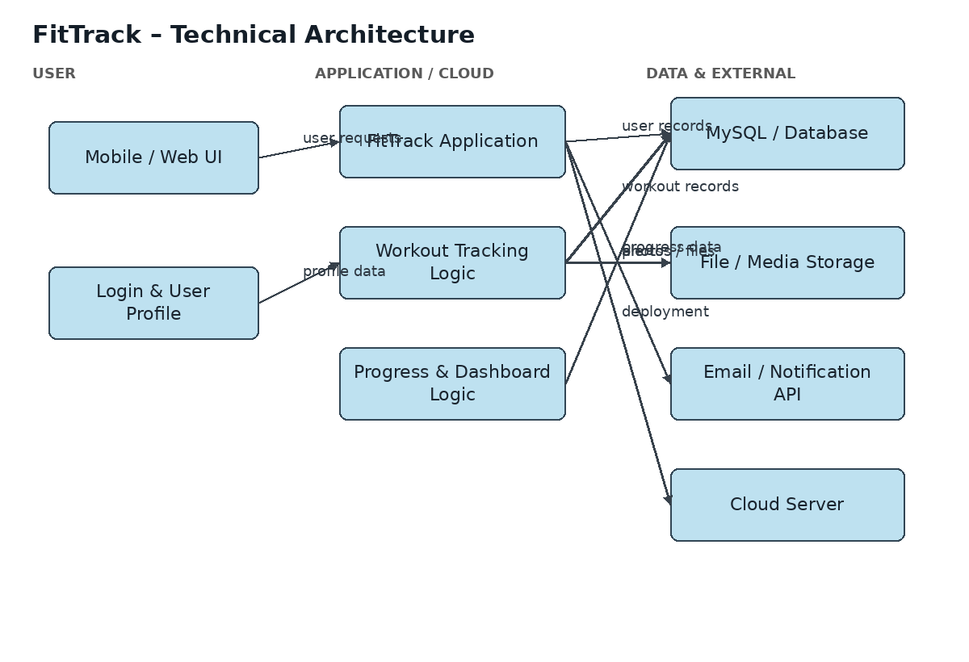
FitTrack Technical Architecture
Guidelines applied: application processes are shown as technology blocks; infrastructure is separated into application/cloud, data and external services; data storage and external notification interfaces are indicated.
Table-1 : Components & Technologies:
S.No | Component | Description | Technology
1 | User Interface | How the user interacts with FitTrack through web/mobile screens. | HTML, CSS, JavaScript
2 | Application Logic-1 | Logic for user registration, login and profile management. | Node.js / Express.js
3 | Application Logic-2 | Logic for workout recording and fitness goal tracking. | JavaScript / Node.js
4 | Application Logic-3 | Logic for progress calculation and dashboard display. | JavaScript
5 | Database | Stores user profiles, workouts, goals and progress records. | MySQL
6 | Cloud Database | Database service on cloud when cloud deployment is used. | Cloud MySQL service
7 | File Storage | Stores profile images or fitness-related media if required. | Local filesystem / Cloud Storage
8 | External API-1 | Used for sending account and workout reminder notifications. | Email / Notification API
9 | External API-2 | Optional external interface for fitness/activity data. | Fitness/Activity API
10 | Machine Learning Model | Not required for the basic FitTrack version. | Not applicable
11 | Infrastructure (Server / Cloud) | Application deployment and hosting. | Local Server / Cloud Server

Table-2: Application Characteristics:
S.No | Characteristics | Description | Technology
1 | Open-Source Frameworks | List the open-source frameworks used. | Node.js / Express.js
2 | Security Implementations | Authentication, password protection and access controls. | Secure authentication / HTTPS
3 | Scalable Architecture | The application can be separated into UI, application logic and database layers. | 3-tier architecture
4 | Availability | The application can be deployed on a server/cloud for continuous access. | Cloud Server / Hosting
5 | Performance | Use optimized database queries and lightweight UI components for faster response. | Database optimization / Caching where required

References:
https://c4model.com/
https://www.ibm.com/cloud/architecture
https://aws.amazon.com/architecture

